Rosario has always been a club about community, and this Pan disability section extends that even further. Our core beliefs for this include:

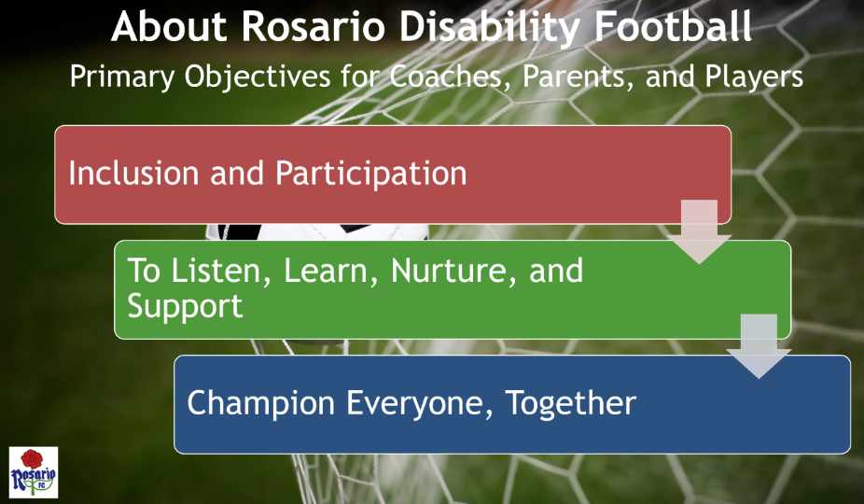

Rosario has worked closely with the IFA on the best approach to set up and run a disability football section. This has included IFA-approved training courses for coaches participating in the initial pilot, with additional coach training continually being reviewed and scheduled with the IFA.

In addition to the standard Rosario training (e.g., Safeguarding), these courses are suggested for volunteers involved with disability players. Rosario aims for volunteers to undertake at least two of these training courses:

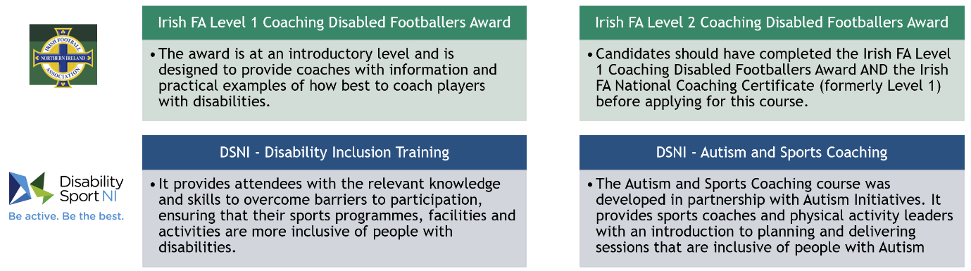

Forward plans.

Rosario is always looking at ways to challenge and improve how we operate, the disability section is no different to this.

- Expand the number of players, and disabilities in scope, increasing participation.
- Review and improve how individual sessions are run, as well as how we cater to individual disabilities.
- Work closely with local schools and charities to promote participation in the Pan disability section.
- Work with the IFA to identify competitions and leagues (at various levels) for our players to participate in
- Work towards setting up a senior section for ages 18+
- Look for further funding to support changes and growth.

Contact Us

<Site Feedback form>
<Social Media links>

Rosario Disability Football is sponsored by Telefonica

